Using IDM Backup Manager

Backing up your Internet Download Manager
Open the IDM Backup Manager. And choose browse button as shown in figure.
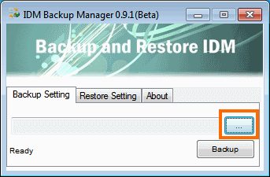

Once you click browse button you get Browse dialog then select backup folder. Then Press Backup Button.
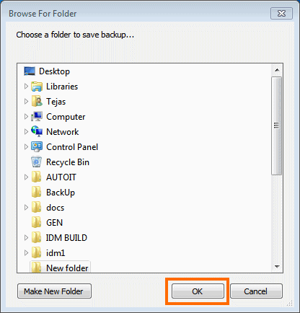

Restoring your Internet Download Manager
Open the IDM Backup Manager. And choose browse button as shown in figure.
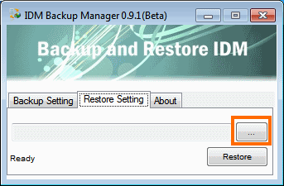
Once you click browse button you get Browse dialog then select Restore folder. Once you press Restore button all the backup data are replaced with IDM(including setting, fragment file)
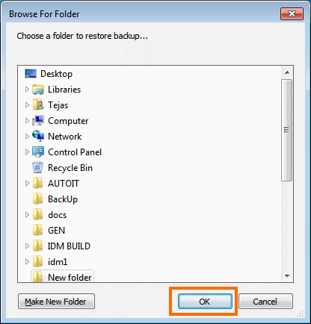

Checking Update
Press the update button to check update as shown in figure.
